1. Cement characterization Do you have clinker phase composition (e.g., C₃S, C₂S, C₃A, C₄AF) or Rietveld-quantified XRD results for the cement? If not available, should the cement be approximated using a standard OPC composition in CemGEMS?
Chinese：
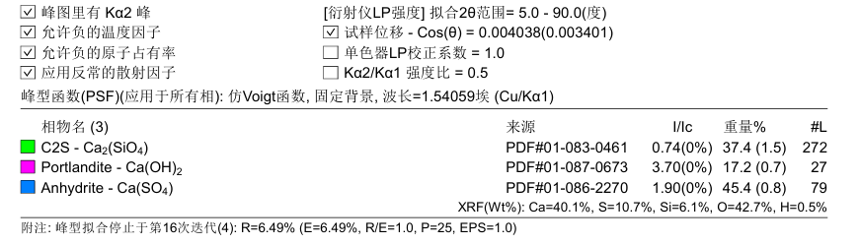
English：
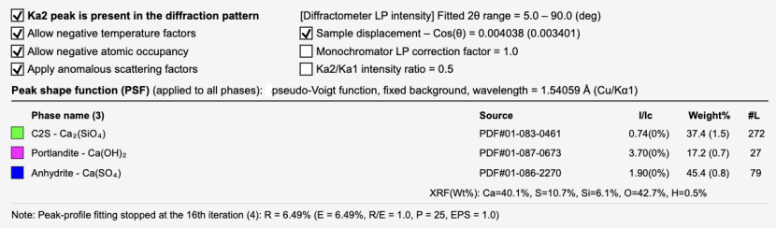
2. Fly ash and coal gangue mineralogy Are quantitative XRD (Rietveld) phase assemblages available for fly ash and coal gangue (e.g., glass content, quartz, mullite, etc.)? If only XRF data are to be used, please confirm that amorphous phases should be modeled based on oxide composition.
Chinese：
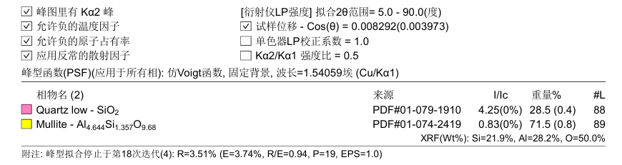
粉煤灰
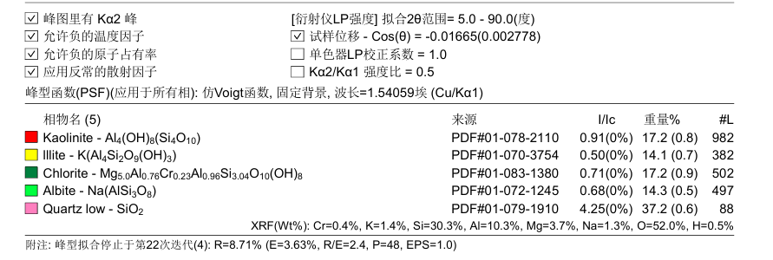
矸石
English：
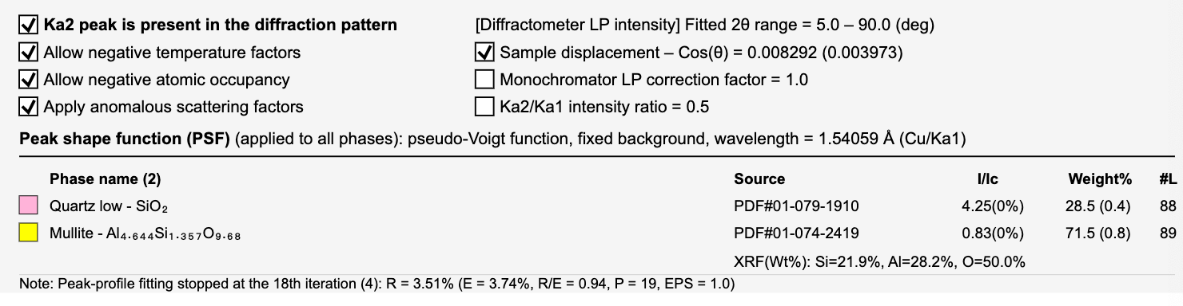
Fly ash
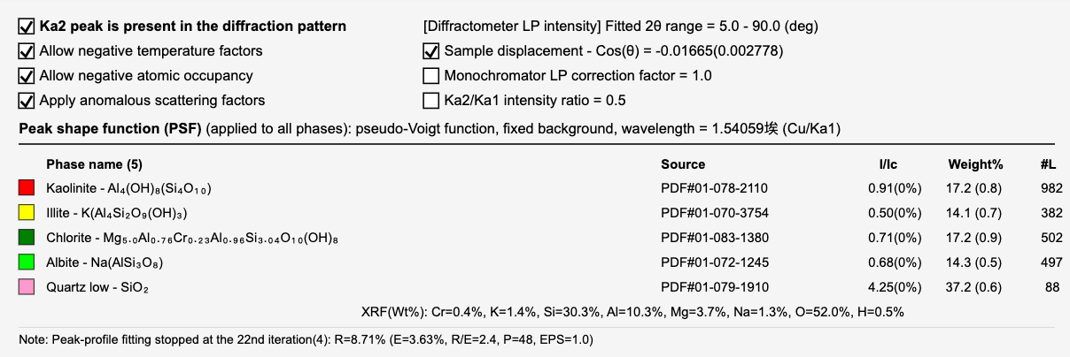
Gangue
3. Sodium silicate details Please confirm whether sodium silicate should be treated as fully dissolved at the initial stage. Should Na and Si be allowed to freely participate in forming N-A-S-H / C-(N)-A-S-H type gels in the thermodynamic model?
Answer: Sodium silicate is treated as being fully dissolved; Na and Si are allowed to freely participate in the formation of N-A-S-H / C-(N)-A-S-H type gels.
4. Carbonation boundary conditions For the CO₂ concentrations (0–40 vol%), should CO₂ be imposed as a fixed gas phase with equilibrium gas–solid interaction, or as incremental CO₂ addition for reaction-path simulations?
Answer: CO₂ is introduced incrementally (stepwise addition).
5. Hydration state assumption Should the system be assumed as fully hydrated before carbonation, or should hydration and carbonation be modeled simultaneously?
Answer: Both hydration and carbonation processes need to be considered simultaneously in the model.
6. Thermodynamic database preference Do you have a preferred database (e.g., Cemdata18 / Cemdata20 / custom GEMS database), or should I proceed with a standard CemGEMS setup?
Answer: Cemdata20

